Suggested social media posts

1.
Did you know 2 people every day die by suicide in Scotland?
We’re supporting Scotland to #AskTellSaveALife.
If you suspect someone may be feeling suicidal, ask them.
It could save their life.
Raise your awareness and prevent suicide: www.bit.ly/AskTellSaveALife
Image to be used:
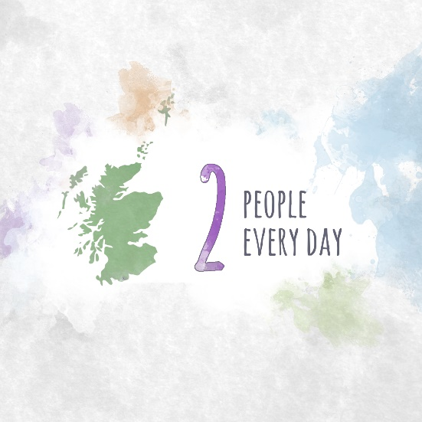
2.

You could help save someone's life just by asking them how they are.
We’re supporting Scotland to #AskTellSaveALife.
If you suspect someone may be feeling suicidal, ask them.
It could save their life.
Raise your awareness and prevent suicide: www.bit.ly/AskTellSaveALife
Image to be used:
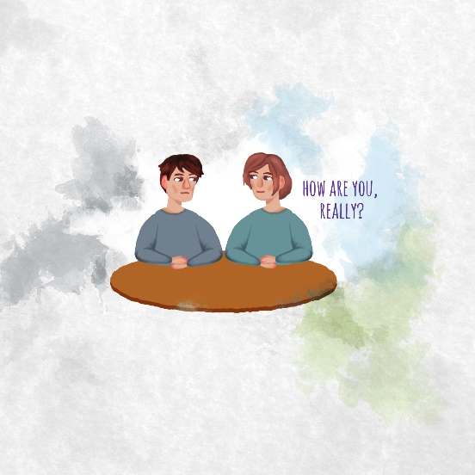

3.

Having a compassionate conversation could save someone's life.
We’re supporting Scotland to #AskTellSaveALife.
If you suspect someone may be feeling suicidal, ask them.
It could save their life.
Raise your awareness and prevent suicide: www.bit.ly/AskTellSaveALife
Image to be used:
