Scottish Smoking Cessation Conference
Tackling health inequalities and supporting our priority groups to quit
Tuesday 21 November 2017
Radisson Blu Hotel, Glasgow

IMPACT REPORT

The aims of the conference were to debate how we:
- Provide holistic / service user centred services
- Ensure services support reduced smoking rates within the poorest communities
- Work in partnership to deliver effective smoking cessation services.

201 people attended the 1-day event. 13 staff were from NHS Health Scotland and a further 5 of the 201 attended from our partnering organisation; Ash Scotland.

Of the 184 delegates, the following professional roles were represented:

- Smoking cessation advisers /front line practitioners/health improvement officers – 77
- Service Managers/senior health improvement officers – 30
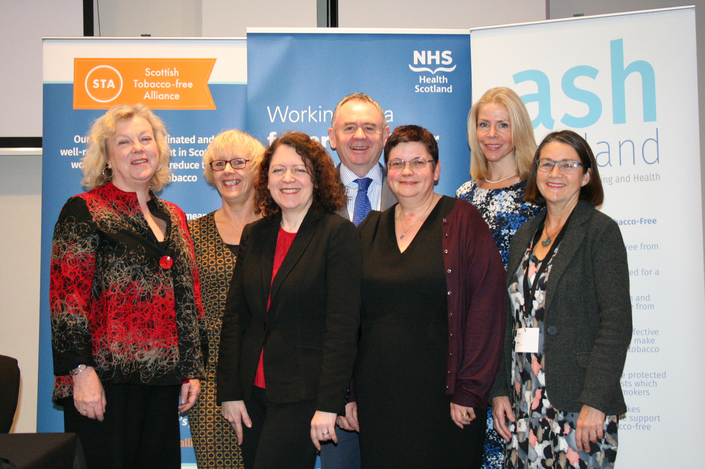Left to right: Amanda Amos, Elaine Mitchell, Sheila Duffy, Gerry McLaughlin, Caroline Smith, Linda Bauld, Ann McNeill
- Researchers – 16
- Nurses/Midwives’ – 32
- Pharmacists - 3
- Policy makers – 3
- Administration - 13
- Analyst – 5
- Students – 3
- None stated - 2

The programme can be found at Appendix A.

Survey results

After the conference, 79 people completed the on-line survey, 42% of delegates. 87% of respondents thought the conference had been excellent or good; no respondent felt that it had been poor.

Headline findings:
- 86% of respondents rated the programme content as either excellent or good. Comments confirmed that the programme was relevant and balanced:

“This year's topic areas were of more relevance than previous years have been for some time; it is my feeling that I, and colleagues from across Scotland, have taken a great deal away as a direct result of attending the 2017 SSCC”

- There was a positive result on the aim of changing an aspect of their work as a result of attending the conference, as illustrated in the following table and graph below:

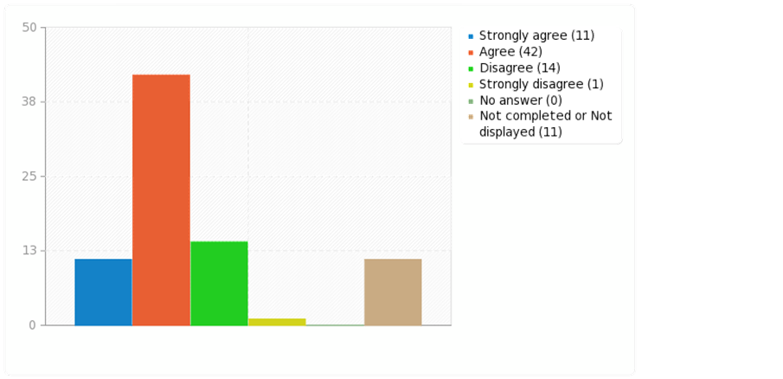

- Some delegates felt that they wanted more clarification on the following:

“ The e-cig message and guidance needs to be clearer- in the session there was still a lot of negativity from smoking cessation advisors, which may prevent smokers from engaging with them if they are on e-cigs or wanting to use e-cigs to give up. Our message has to be the same!”

“Further information required regarding smoking and mental health”

“It would have been helpful to have the attendance of staff from SPS headquarters who are actively involved in the action plan to implement smoke free prisons as most NHS staff seemed to be confused about timelines re same. It meant there was more questions with no one in a position to advise.”

- Respondents also felt that they had made new work related contacts as a result of attending the conference with no respondents disagreeing.

- 82% of respondents agreed or strongly agreed that there was enough opportunity for discussions and questions.

Some really positive feedback was received on the Smoking in Mental Health sessions:

“The mental health workshop was really useful and prompted me to think outside of the box. It has energised me into wanting to develop local champions”

“The key messages were targeting our prioritised groups and thinking out the box to reach these clients. The information regarding the prescription of Champix for people with mental health conditions was also extremely helpful and has given me more confidence when discussing this with clients.
Questions about the future of the conference”

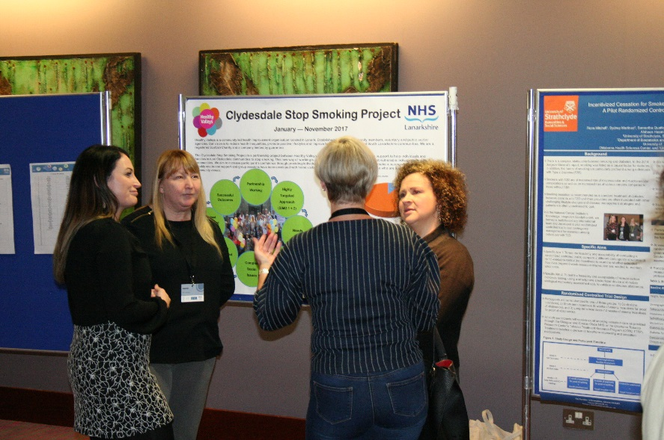

In 2018, there will be a review of the learning and networking opportunities available to the smoking cessation community. Some of the questions will be asked of the conference:
- What other learning and networking opportunities are available throughout the year for practitioners?
- What resource is allocated by NHSHS to other public health priorities for conferences?
- What digital channels could be maximised e.g. webinars?
- Focus of next year’s conference?
  - Smoke free prisons
  - Extend from cessation to prevention/protection and role of local authorities/CPPs in contributing
- Role of ASH Scotland in the planning and delivery?

For further information about the Tobacco Control programme, please contact Debbie Sigerson, NHS Health Scotland. E-mail address: debbie.sigerson@nhs.net

Appendix A

Scottish Smoking Cessation Conference 2017 Programme

Programme

09:00 Registration, refreshments, networking, marketplace and poster presentations

09:30 Welcome and introduction from the Morning Chair
Gerry McLaughlin, Chief Executive, NHS Health Scotland

09:40 Keynote addresses:
Tackling health inequalities: supporting priority groups to stop smoking

- An overview on smoking and inequalities in Scotland - Prof Amanda Amos (Professor of Health Promotion), University of Edinburgh
- Systematic review on inequalities and smoking cessation support/services in the UK (CRUK funded research) – Dr Caroline Smith (Research Fellow), University of Edinburgh
- Supporting smokers with mental health problems, Prof Ann McNeill (Professor of Tobacco Addiction), Kings College London & Depute Director of UKCTAS
- Smoking in pregnancy, Prof Linda Bauld, University of Stirling & Depute Director of UKCTAS

11:10 Networking, refreshments, marketplace and poster presentations

11:40 Themed discussion sessions

 | Theme | Presenter / Chair
A | How do we best engage and support people with mental health problems? | Presenter: Prof Ann McNeill  Chair: Fiona Lockett
B | How do we engage and support those who wish to use e-cigarettes to stop smoking? | Presenter: Prof Linda Bauld  Chair: Sheila Duffy
C | Youth prevention and cessation services  - How can we prevent adolescences from smoking and help those who do to stop?  - What partnerships need to be developed / embedded? What is the role of wider partners and how do we effectively engage them? e.g. schools, third sector, vocational training / employability providers, e.g. Skills Scotland | Presenter: Fiona Dobbie to present ASSIST work  Chair: Amanda Amos
D | Improving the effectiveness and reach of NHS support for smoking cessation in pregnancy | Presenter: Dianne Woodall, Lead Tobacco Commissioner, Durham County Council to present BabyClear  Chair: Lesley Allan
E | How do we protect from the harms of second-hand smoke? | Presenter: Dr Sean Semple, Aberdeen University  Chair: Karen Mather
F | Smoke free prisons | Presenters: Dr Helen Sweeting, University of Glasgow with Douglas Eadie (University of Stirling) or Richard Purves (University of Stirling)  Chair: Helen Sweeting

12:40 Networking, lunch, marketplace and poster presentations

13:40 Remarks from the Afternoon Chair
Sheila Duffy, Chief Executive, ASH Scotland

13:50 A new identity for Scotland’s smoking cessation service: from planning to placement
Elaine Mitchell, Scottish Government and Jim Kelly, Karen Kneale & Tracy Milne, Story UK

[14:20 Move to parallel sessions]

14:25 Parallel sessions

15:30 End of event and networking opportunities

