Suggested social media posts

Its #WorldMentalHealthDay & this year’s theme is preventing suicide. Throughout the day & beyond we will be asking Scotland to #AskTellSaveALife. This animation will help to raise your awareness & prevent suicide: www.bit.ly/AskTellSaveALife Help us spread the word to #PreventSuicide

Image:
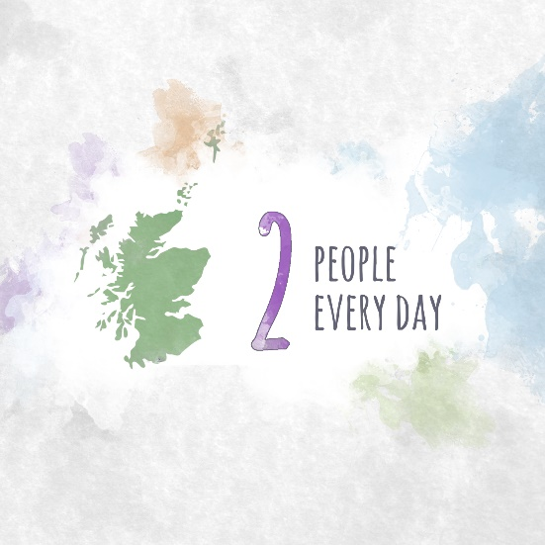

2. You could help save someone's life just by asking them how they are. This #WorldMentalHealthDay we are supporting Scotland to #AskTellSaveALife. This animation will help to raise your awareness and prevent suicide: www.bit.ly/AskTellSaveALife

Suggested image to use:
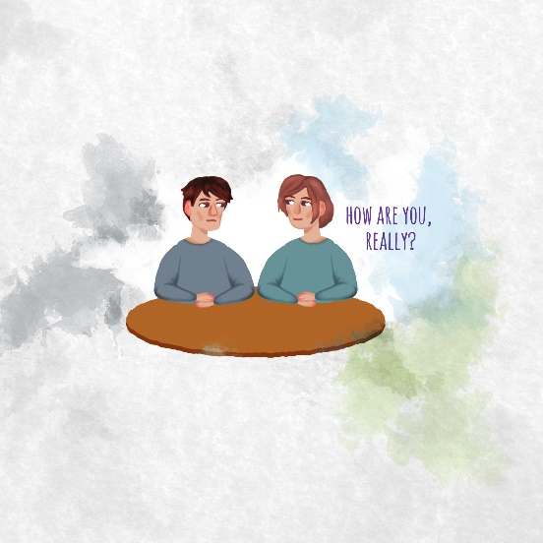

3. Have a compassionate conversation this #WorldMentalHealthDay & help Scotland to #AskTellSaveALife. Someone you know may be feeling suicidal. Asking them could help save their life.
This animation will help raise your awareness and prevent suicide: www.bit.ly/AskTellSaveALife

Suggested image to use:
