International Making Place Conference
10th June 2019
Glasgow

Parallel Sessions Location Guide

The Lighthouse (Gallery 2)
11 Mitchell Lane, Glasgow G1 3NU
Morning sessions: Parallel session 1
Afternoon sessions: Parallel session 7

Meet your facilitator at the back of the main auditorium room you will be escorted to the venue (10:50 am for morning sessions and 13:20 for the afternoon sessions).

Alternatively, if you prefer to get there independently please follow the map below (10-15 min walk) and ensure you arrive at the Lighthouse for 11:00 or 13.30 as the sessions will start promptly.

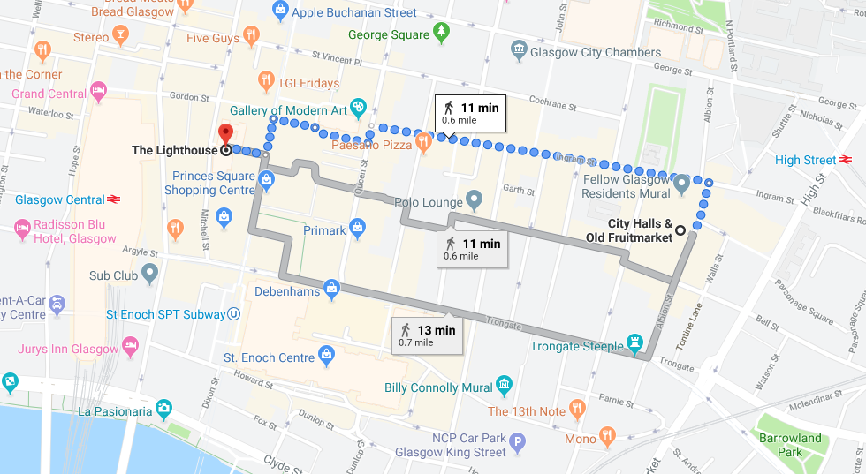

Balcony
Old Fruitmarket
87-101 Albion St, Glasgow G1 1NQ
Morning sessions: Parallel session 5
Afternoon sessions: Parallel session 11

The Balcony where the exhibition sessions 5 (morning) and 11 (afternoon) are held is located in the main conference centre. Staff will direct you to the Balcony if necessary.

Scottish Youth Theatre
105 Brunswick Street, Glasgow G1 1TF
Morning sessions: Parallel session 2,3 & 4
Afternoon sessions: Parallel session 8, 9 & 10

Meet your facilitator in the registration area in the foyer and you will be escorted to the venue (10:50 am for morning sessions and 13:20 for the afternoon sessions).

Alternatively, if you prefer to get there independently please follow the map below (5 min walk) and ensure you arrive at the Scottish Youth Theatre for 11:00 or 13:30 as the sessions will start promptly.

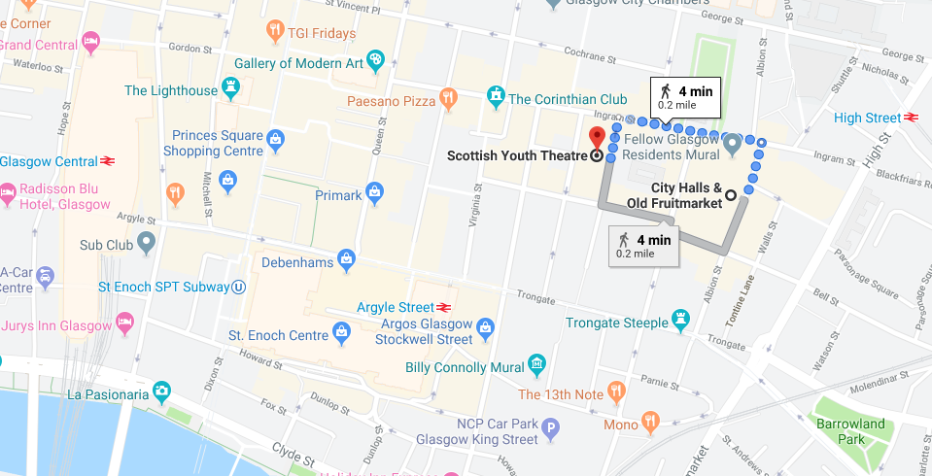

Govanhill
(Site visit)
Morning sessions: Parallel session 6

Coach transport is arranged for those attending the site visit session (parallel session 6).
Meet your facilitator at the front of the main auditorium and you will be escorted to the venue (10:50 am).

Woodside Community Health and Care Centre
(Site visit)
Afternoon sessions: Parallel session 12

Coach transport is arranged for those attending the site visit session (parallel session 12).
Meet your facilitator at the front of the main auditorium and you will be escorted to the venue (13:20 pm).

